***Components Manual***

* **NodeMcu**

NodeMCU is an open source IoT platform. Which includes firmware which runs on the ESP8266 Wi-Fi Module from Espressif Systems, and hardware which is based on the ESP-12 module.

The [NodeMCU](http://www.nodemcu.com/index_en.html) (Node Microcontroller Unit) is an open source software and hardware development environment that is built around a very inexpensive System-on-a-Chip (SoC) called the [ESP8266](https://en.wikipedia.org/wiki/ESP8266) It has got Micro USB slot that can be directly connected to the computer or other USB host devices.

***Features***

* Open-source
* Interactive
* Programmable
* Low cost
* Simple
* Smart
* WI-FI enabled
* USB-TTL included
* Plug & Play

***Specifications***

* **Developer:** ESP8266 Open Source Community
* **Type:**  Single-board microcontroller
* **Operating system:** XTOS
* **CPU:** ESP8266
* **Memory:** 128kBytes
* **Storage:** 4Mbytes
* **Power by:** USB
* **Power Voltage:** 3v ,5v (used with 3.3v Regulator which inbuilt on Board using Pin VIN)
* **Code:** Arduino CPP
* **IDE Used:** Arduino IDE
* **GPIO:** 10

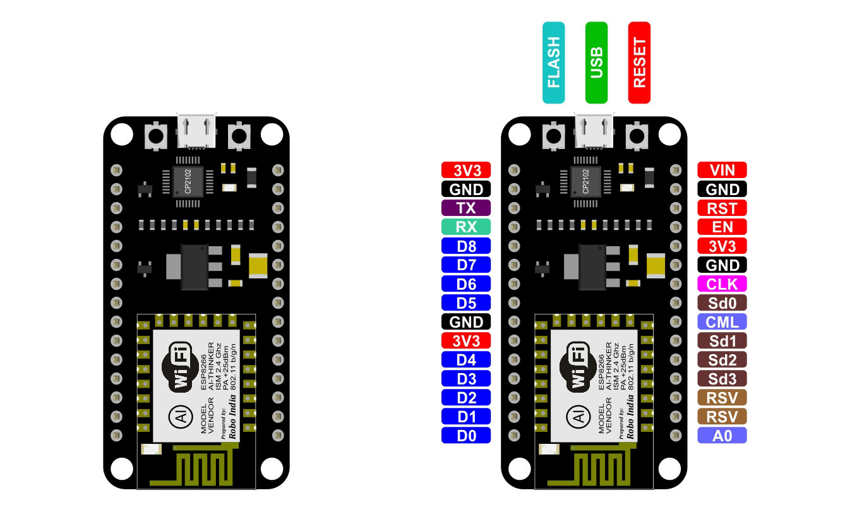

**NodeMCU Pin maching guide**

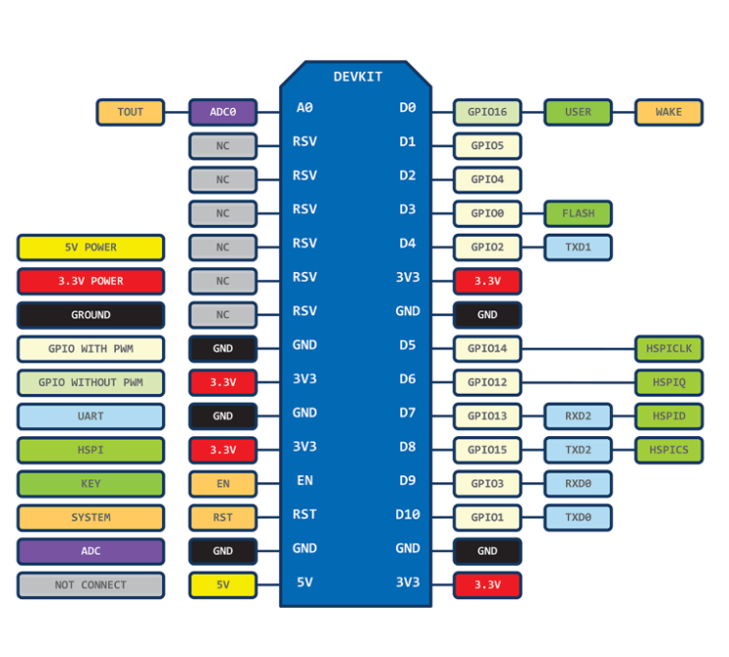

* **Breadboard and Jumper wires.**
* A breadboard is used to build and test circuits quickly before finalizing any circuit design. The breadboard has many holes into which circuit components like ICs and resistors can be inserted.
* The term "jumper wire" simply refers to a conducting wire that establishes an electrical connection between two points in a circuit.

 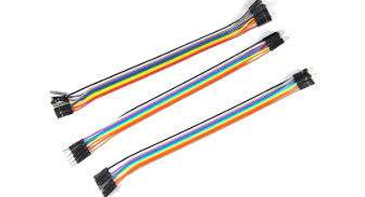

Breadboard Jumper wires

* **Bread board power supply (MB102)**

It’s used to supply external power to the breadboard and other components.

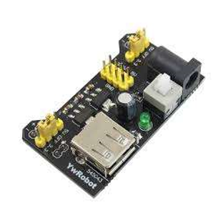

* **LED and LDR**
* A light-emitting diode (**LED**) is a semiconductor light source that emits light when current flows through it.
* A Light Dependent Resistor(**LDR**) or Photoresistor, which is a passive electronic component, basically a resistor which has a resistance that varies depending of the light intensity.

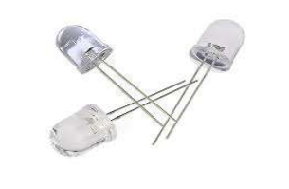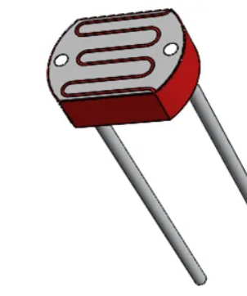

LED LDR

* **Buzzer**

A buzzer or beeper is an audio signalling device, which may be mechanical, electromechanical, or piezoelectric (piezo for short). Typical uses of buzzers and beepers include alarm devices, timers, and confirmation of user input such as a mouse click or keystroke.

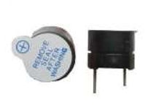

* **Motor Driver**

It’s a little current amplifier the function of motor driver is to take a low current control signal and turn it into higher current signal that can drive a motor.

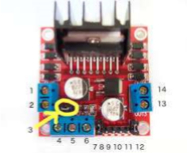

* **DC motor**

A DC motor is any of its class of rotary electrical machines that converts direct current electrical energy into mechanical energy. Nearly all DC motors have same internal mechanisms.

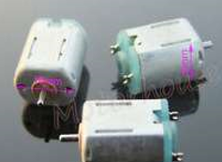

* **Servo motor(SG90)**

A servo motor is a rotary actuator or motor that allows for a precise control in terms of angular position, acceleration and velocity, capabilities that a regular motor does not have. It makes use of a regular motor and pairs it with a sensor for position feedback. The controller is the most sophisticated part of the servo motor, as it is specifically designed for the purpose.

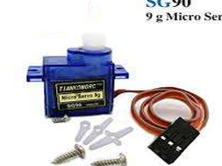

* **Ultrasonic Sensor(HC-SR06)**

Ultrasonic sensors work by emitting sound waves at a frequency too high for humans to hear. They then wait for the sound to be reflected back, calculating distance based on the time required. This is similar to how radar measures the time it takes a radio wave to return after hitting an object.

* It has Frequency of 20KHz and Measuring range of 2Cm to 30Cm.

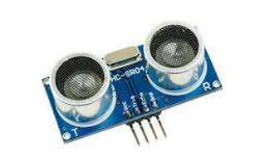

* **Temperature humidity sensor(DHT11)**

The DHT11 is a basic, ultra-low-cost digital temperature and humidity sensor. It uses a capacitive humidity sensor and a thermistor to measure the surrounding air, and spits out a digital signal on the data pin (no analog input pins needed). Its fairly simple to use, but requires careful timing to grab data. The only real downside of this sensor is you can only get new data from it once every 2 seconds, so when using our library, sensor readings can be up to 2 seconds old.

* Good for 20-80% humidity readings with 5% accuracy
* Good for 0-50°C temperature readings ±2°C accuracy

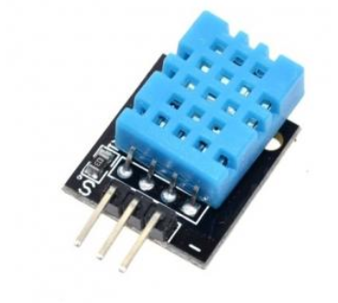

* **Smoke and combustible gas sensor(MQ2)**

Gas Sensor (MQ2) detects combustible gasses and smoke. The Grove - Gas Sensor(MQ2) module is useful for gas leakage detection (in home and industry). It can detect combustible gas and smoke. The output voltage from the Gas sensor increases when the concentration of gas.

The analog output voltage provided by the sensor changes in proportional to the concentration of smoke/gas. The greater the gas concentration, the higher is the output voltage. While lesser gas concentration results in low output voltage.

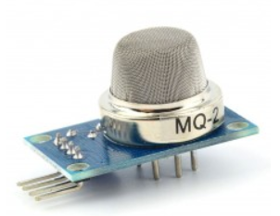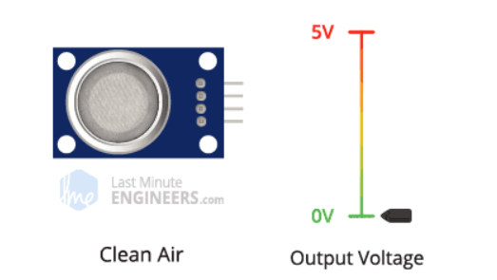

* **Pyroelectric Infrared Sensor (HC-SR501)**

The PIR sensor stands for Passive Infrared sensor. It is a low cost sensor which can detect the presence of Human beings or animals.

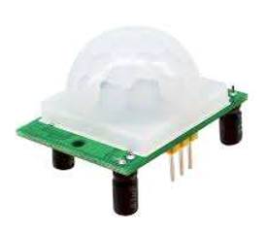

***How it works?***

If you didn’t know, all objects with a temperature above Absolute Zero (0 Kelvin / -273.15 °C) emit heat energy in the form of infrared radiation, including human bodies. The hotter an object is, the more radiation it emits.

PIR sensor is specially designed to detect such levels of infrared radiation. It basically consists of two main parts: **A Pyroelectric Sensor** and A special lens called **Fresnel lens** which focuses the infrared signals onto the pyroelectric sensor.

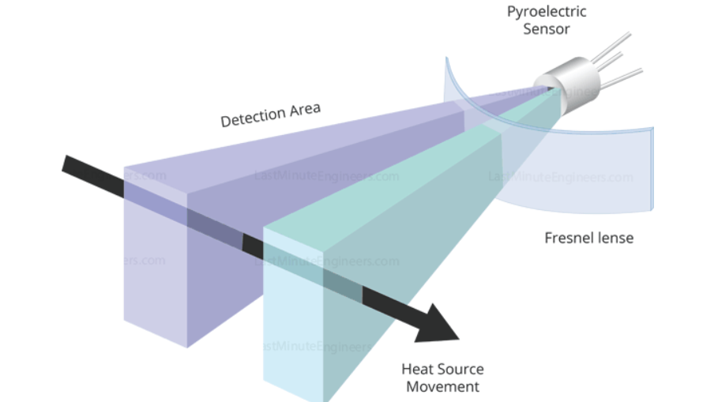

it first intercepts one half of the PIR sensor, which causes a positive differential change between the two halves. When the warm body leaves the sensing area, the reverse happens, whereby the sensor generates a negative differential change. The corresponding pulse of signals results in the sensor setting its output pin high.

